Come together day

bbq ribs/chicken leg Quarter gRILL-off

bRANSFORD COMMUNITY CENTER

1519 jOHN L pATTERSON

springfield, tennessee

Saturday, August 7, 2021
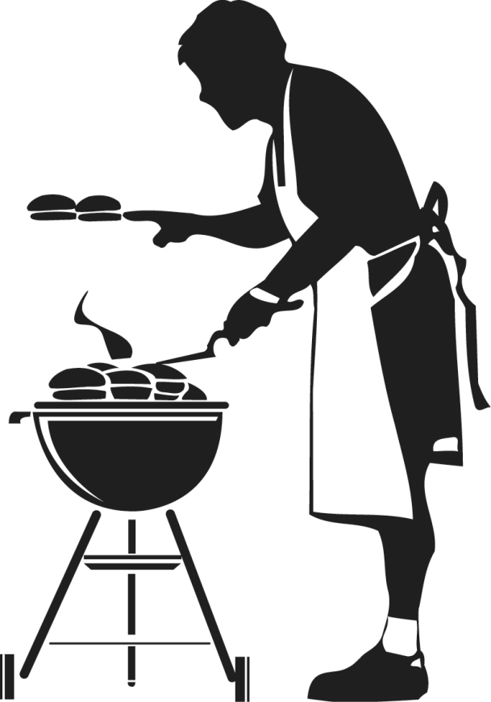 |  | General Rules:  An Entry Fee of $35.00 will be charged for BBQ Ribs or Chicken. If contestant enters ribs and chicken an Entry fee of $70 will be charged. If contestants plan to also sale Ribs or Chicken to the public an additional vendor fee of $35.00 is required.  - Each contestant will bring Bone - in Pork Spare-Ribs and/or Chicken Leg Quarters.  - There are 4 Judges.  - Charcoal or wood grills are acceptable – you must bring your own grill.  - No holes or dug pits are permitted.  - No Gas Grills  - No par-boiling or frying in oil is permitted.  - All ribs and chicken leg quarters must be raw, uncooked and in original package at check-in. Meat will be inspected by a Come Together Day Official at check –in.  - Prior preparation such as marinating and seasoning is not permitted. All preparation of meat, sauces, rubs and marinades must be done on contest site.  - Check-in and set-up time is from 9 am to 10 am.  - No Alcoholic beverages permitted in or on Ribs or Chicken, in sauces, marinades rubs or consumed on premises.  All Chicken Leg Quarters must be finished for judging at 5:30 pm.  All ribs must be finished for judging at 5:30 pm.
Deadline: August 1st
Name: __________________________________________________________ Business Name: __________________________________________
Phone Number: _______________________________________________ Email Address: _________________________________________
I will be cooking: Ribs Chicken Both
I would like to be a vendor (For an additional $35): Yes No

